Anglais

Mail

Gettins-openings-salutations

* Dear Sir/Madam
* Dear Miss, Dear Mrs. Jones
* Mear Mr., Dear Ms. Mx(geneder neutral).
* Dear ms. Jones
* Ms. Jones
* Dear Hiring Manager
* Good morning/afternoon John
* John
* Greetings, Hello, hi ,Hi there, Hey
* To whom it may concern è “A qui de droit”.

Exemple Mail

Subject: Exam missed January 12

Hello/Dear ms. Kinskley

As I wad sick on January 12, I was not able to/unable to attend your class that day and did not take the test.

Please find/You will fund attached the medical certificate wich I hope will excuse my absence.

Could you please let me know I might be able to retake the exam?

I’am sorry for any inconvenience this may cause (you).

Thank you in advance for your understanding.

Best regards

Thomas Pinchon

Groupe 1.

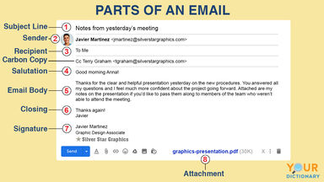

* If we want to “put someone on copy” we use “Carbon copy” or “CC”. But how do we send a secret copy to someone without informing all the recipients? (in French: “cci”)
* Blind Cabon Copy (Bcc).

Int this case, the address doesn’t appear.